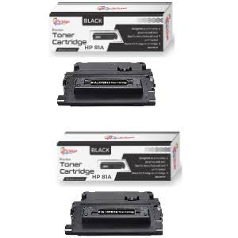
- HP M604 M605 Compatible Black Toner Cartridge 2Pack 81A
R 800,00

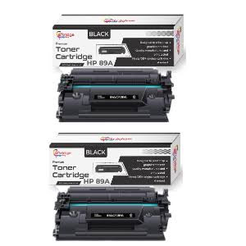
- HP CF289A Generic 2-Pack Toners Cartridge 89A
R 1200,00

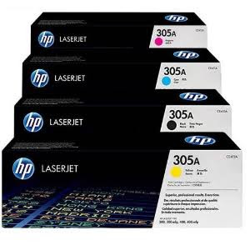
- Hp LaserJet Pro 300,400mfp Original Multipack Toner Cartridges 305A
R 4500,00

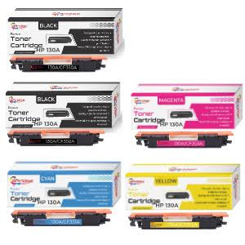
- Hp CF350A Compatible Value Pack +1 Extra Black Toners Cartridge 130A
R800,00

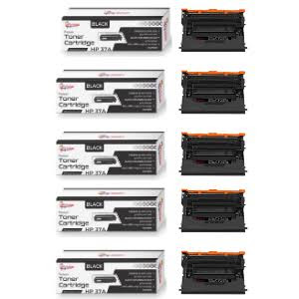
- HP CF237A Generic 5-Pack Toners Cartridge 37A
R 2600,00

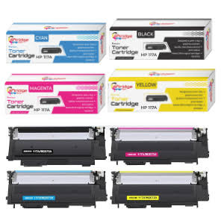
- HP W2070A/W2071A/W2072A/W2073A Compatible Multipack Toner Cartridges 117A
R 1200,00
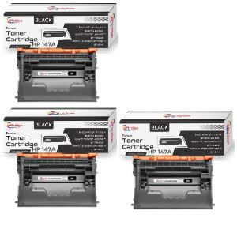
- HP W1470A Generic 3-Pack Laser Toners Cartridge 147A
R 4300,00

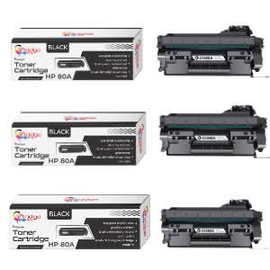
- HP CF280A Generic 3-Pack Toners Cartridge 80A
R 510,00

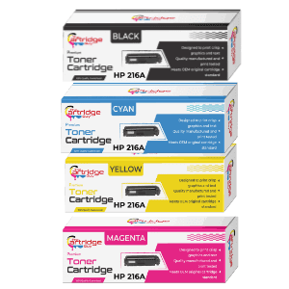
- HP M182,MFP M183 216A Compatible Toner Cartridge W2410A,W2411A,W2412A,W2413A Multipack
R 2600,00
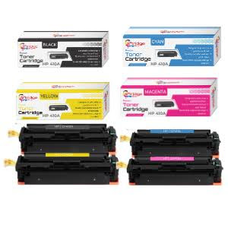
- Hp LaserJet Pro M377, M452 Compatible Multipack Toner Cartridge 410A
R 800,00

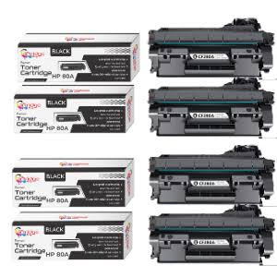
- HP CF280A Generic 4-Pack Toners Cartridge 80A
R 600,00

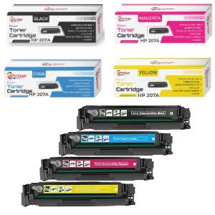
- Hp Pro M255 ,M283 Compatible Value Pack Toner Cartridges 207A
R 2600,00
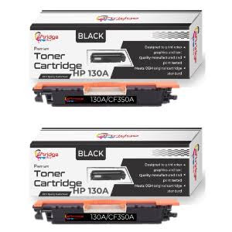
- HP LaserJet Pro MFP M177fw, M178 Compatible 2Pack Black Toner Cartridges 130A
R 350,00

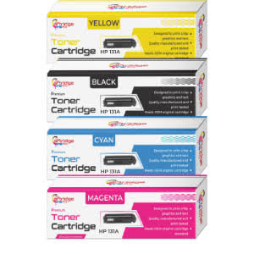
- Hp Pro M251 MFP M276 Compatible Multipack Toner Cartridge 131A
R800,00

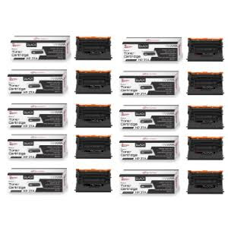
- HP CF237A Generic 10-Pack Toners Cartridge 37A
R 650,00
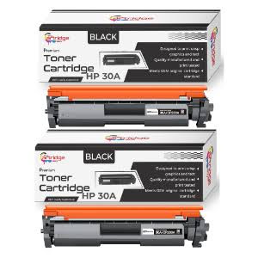
- HP LaserJet M203, MFP M 227 Fdw Compatible Black 2 Pack Toner Cartridges 30A
R 450,00

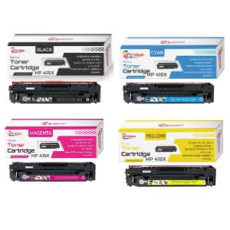
- Hp M455dn/M454dn Compatible B/C/M/Y Generic Value Pack Toners 415X
R 5600,00

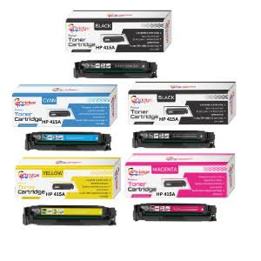
- Hp Compatible Value Pack +1 Extra Black Toners Cartridge 415A
R 3900,00
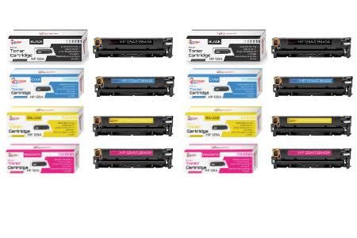
- Hp LaserJet CM1312 CP1215 Compatible Value Pack x 2 Toner Cartridges 125A
R 1900,00

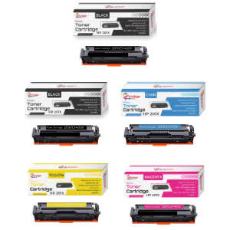
- HP CF400X / CF401X / CF402X / CF403X Compatible Multipack+ Extra Black Toner Cartridges 201X
R 1200,00

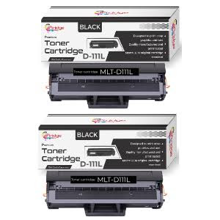
- Samsung Xpress M2022 Compatible 2PACK Black Toner Cartridges MLT-D111L
R360,00
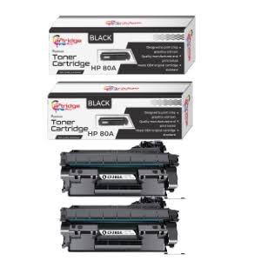
- HP CF280A Compatible 2Pack Black Toner Cartridges 80A
R 450,00

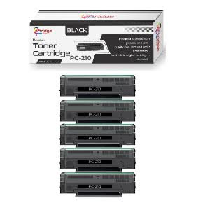
- Pantum P2200,P2500 Generic 5-Pack Toners PC-210
R 800,00

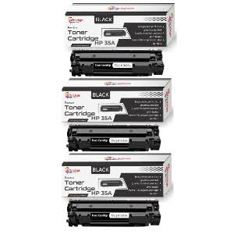
- Hp LaserJet P1002 Compatible 3PACK Black Toner Cartridges 35A
R 480,00
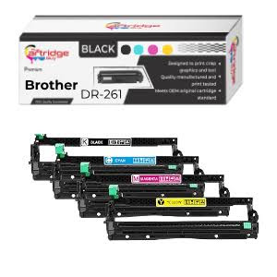
- Compatible Brother DR-261CL / DR261 (B/C/M/Y) Drum Unit
R 1100,00

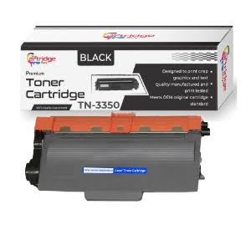
- Brother HL-5450DN /HL-5440D Compatible Black Toner Cartridge TN-3350
R210,00

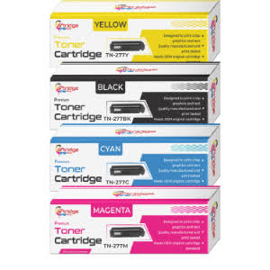
- Brother MFC-L3750CDW DCP-L3551CDW Compatible Multipack Toner Cartridges TN277
R 700,00
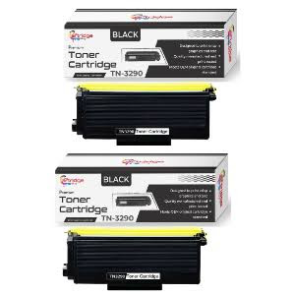
- Brother HL5340D / HL5350DN Compatible 2PACK Toner Cartridges TN-3290
R 350,00

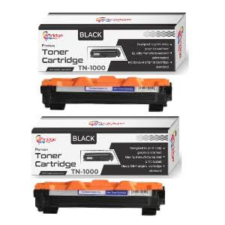
- Brother TN 1000 Compatible Black Set Of 2 Toner Cartridges
R 270,00

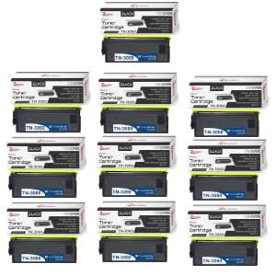
- Brother HL-5150D,MFC-8220 Generic 10Pack Black Toner Cartridges TN-3060
R 1800,00
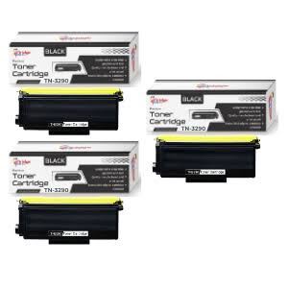
- Brother HL5340D / HL5350DN Compatible 3PACK Black Toner Cartridges TN-3290
R600,00

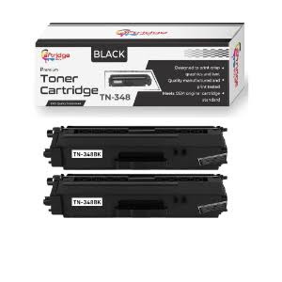
- Brother MFC9460CDN, MFC9970CDW Generic 2Pack Black Toner Cartridges TN-348
R 450,00

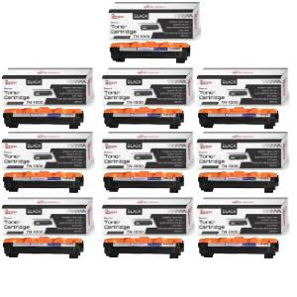
- Brother HL-1110 - HL-1111 Compatible 12PACK Black Toner Cartridges TN-1000
R 1800,00
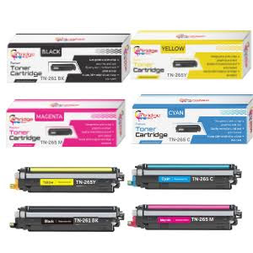
- Brother DCP-9020 CDW/ HL-3140 CW Generic Value Pack Toners TN265/TN261
R800,00

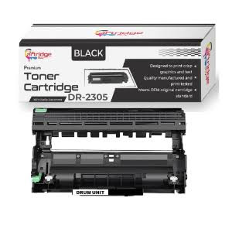
- Brother MFCL2740DW Generic Black Drum Unit DR-2305
R 240,00

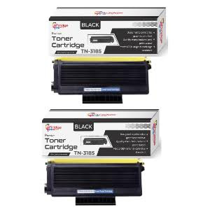
- Brother HL5250DN/ HL5270DN Compatible 2PACK Black Toner Cartridges TN-3185
R 450,00
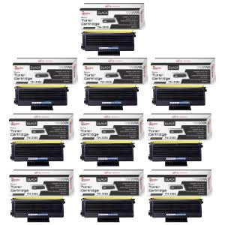
- Brother HL5250DN / HL5270DN Compatible 10PACK Black Toner Cartridges TN-3185
R 2100,00

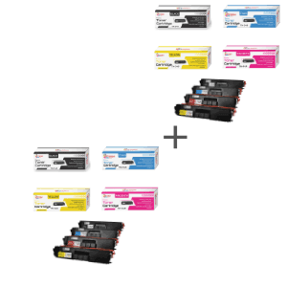
- Brother MFC-9970CDW, MFC9460CDN Generic Double Value Pack Toner Cartridges TN-348
R 2100,00

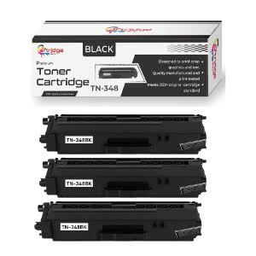
- Brother HL4150CDN, HL4570CDW Generic 3Pack Black Toner Cartridges TN-348
R 700,00
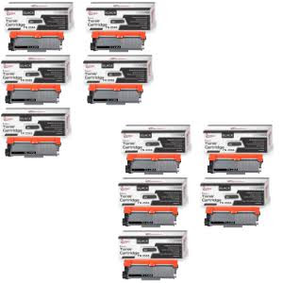
- Brother DCP-L2540DW / HL-L2320D Generic 10Pack Black Toner Cartridges TN-2355
R 1800,00

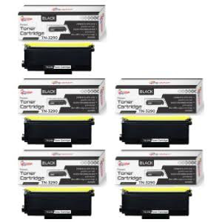
- Brother MFC8880DN MFC8890DW Compatible 5PACK Toner Cartridges TN-3290
R 850,00

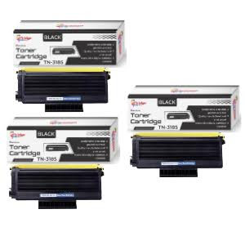
- Brother HL5240 / HL5250DN Compatible 3PACK Black Toner Cartridges TN-3185
R 650,00

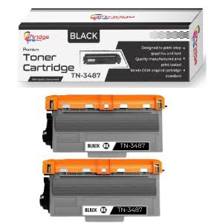
- Brother MFC-L6900DW Generic 2-Pack Black Toner Cartridges TN-3487
R 660

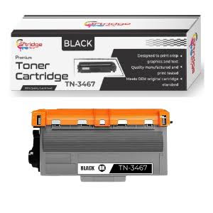
- Brother HL-5270 , HL-5250 Generic Black Toner Cartridge TN-3467
R280

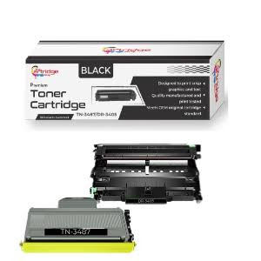
45.Brother MFC-L6900DW, HL-L6400DW Compatible Drum Unit & Toner Set DR 3405 & TN 3487
R 480,00
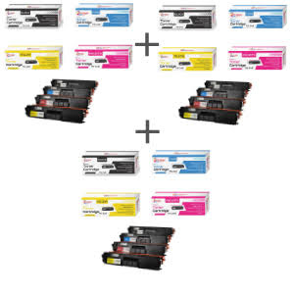
- Brother MFC-9970CDW Generic 3x Value Pack Toner Cartridges TN-348
R3800,00

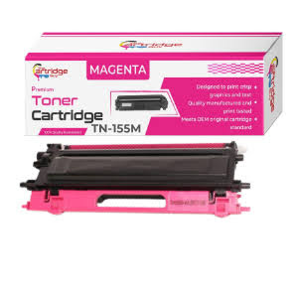
46.Brother HL-4040CN Compatible Magenta Toner Cartridge TN-155
R 290

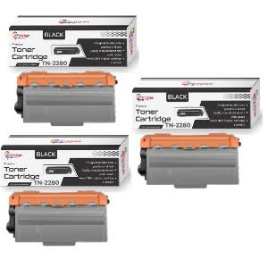
47.Brother MFC-7860DW, MFC-77360 Generic 3Pack Black Toner Cartridges TN-2280
R 490,00

Cartridge and ink Type

- AI-B673C COMPATIBLE BROTHER 673C CARTIDGE
- AI-B673M COMPATIBLE BROTHER 673M CATRIDGE
- AI-B673Y COMPATIBLE BROTHER 673Y CARTRIDGE
- AI-B675C COMPATIBLE BROTHER 675C CARTRIDGE
- AI-B675M COMPATIBLE BROTHER 675M CARTRIDGE
- AI-B675Y COMPATIBLE BROTHER 675Y CARTRIDGE
- AI-B679BK COMPATIBLE BROTHER 679BK CARTRIDGE
- AI- B67BK COMPATIBLE BROTHER LC67BK CARTRIDGE
- AI-B67C COMPATIBLE BROTHER LC67C CARTRIDGE
- AI-B67M COMPATIBLE BROTHER LC67M CARTRIDGE
- AI-B67Y COMPATABLE BROTHER LC67Y CARTRIDGE
- AI-B75BK COMPATIBLE BROTHER LC75BK CARTRIDGE
- AI-B75C COMPATIBLE BROTHER LC75C CARTRIDGE
- AI-B75M COMPATIBLE BROTHER LC75M CARTRIDGE
- AI-B75Y COMPATIBLE BROTHER LC75Y CARTRIDGE
- AI-B39BK COMPATIBLE BROTHER B39BK CARTRIDGE
- AI-B39C COMPATIBLE BROTHER B39C CARTRIDGE
- AI-B39M COMPATIBLE BROTHER B39M CARTRIDGE
- AI-B39Y COMPATIBLE BROTHER B39Y CARTRIDGE
- AI-B47BK COMPATIBLE BROTHER LC-47BK CARTRIDGE
- AI-B47C COMPATIBLE BROTHERS LC-47C CARTRIDGE
- AI-B47M COMPATIBLE BROTHER LC-47Y CARTRIDGE
- AI-B535C COMPATIBLE BROTHER LC535C CARTRIDGE
- AI-B535M COMPATIBLE BROTHER LC535M CARTRIDGE
- AI-B535Y COMPATIBLE BROTHER LC535Y CARTRIDGE
- AI-B539BK COMPATIBLE BROTHER LC539BK CARTRIDGE
- AI-B563BK XL COMPATIBLE BROTHER 563BK CARTRIDGE
- AI-B563C XL COMPATIBLE BROTHER 563C CARTRIDGE
- AI-B563M XL COMPATIBLE BROTHER 563M CARTRIDGE
- AI-B563Y XL COMPATABLE BROTHER 563Y CARTRIDGE
- AI-B565C XL COMPATABLE BROTHER LC565C CARTRIDGE
- AI-B565M XL COMPATIBLE BROTHER LC565M CARTRIDGE
- AI-B565Y XL COMPATIBLE BROTHER LC565Y CARTRIDGE
- AI-B569BK XL COMPATABLE BROTHER LC569BK XL CARTRIDGE
- AI-B57BK COMPATIBLE BROTHER B57BK CARTRIDGE
- AI-B57C COMPATIBLE BROTHER B57C CARTRIDGE
- AI-B57M COMPATIBLE BROTHER B57M CARTRIDGE
- AL-B57Y COMPATIBLE BROTHER B57Y CARTRIDGE
- AI-B673BK COMPATIBLE BROTHER 673BK CARTRIDGE
- AI-C1400BK COMPATIBLE CANON 1400BLK CARTRIDGE
- AI-C1400C COMPATIBLE CANON 1400 CYAN CARTRIDGE
- AI-C1400M COMPATIBLE CANON 1400MAG CARTRIDGE
- AI-C1400Y COMPATIBLE CANON 1400 YEL CARTRIDGE
- AI-C2400BK COMPATIBLE PGI-2400BK CARTRIDGE
- AI-C2400C COMPATIBLE PGI-2400C CARTRIDGE
- AI-C2400M COMPATIBLE PGI-2400M CARRTIDGE
- AI-C2400Y COMPATIBLE PGI-2400Y CARTRIDGE
- AI-C425BK COMPATIBLE CANON 425BK CARTRIDGE
- AI-C426BK COMPATIBLE CANON 426BK CARTRIDGE
- AI-C426C COMPATIBLE CANON 426C CARTRIDGE
- AI-C426G COMPATIBLE 426G CARTRIDGE
- AI-C426M COMPATIBLE CANON 426M CARTRIDGE
- AI-C426Y COMPATIBLE CANON 426Y CARTRIDGE
- AI-C450BK COMATIBLE CANON PGI-450BK CARTRIDGE
- AI-C451BK CAMPATIBLE CANON CLI-451BK CARRIDGE
- AI-C451C COMPATIBLE CANON CLI-451C CARTRIDGE
- AI-C451G COMPATIBLE C451 GREY CARTRIDGE
- AI-C451M COMPATIBLE CANON CLI-451M CARTRIDGE
- AI-C451Y COMPATIBLE CANON CLI-451Y CARTRIDGE
- AI-C470BK COMPATIBLE CANON 470BK CARTRIDGE
- AI-C471BK COMPATIBLE CANON 471BK CARTRIDGE
- AI-C471C COMPATIBLE CANON 471C CARTRIDGE
- AI-C471G COMPATIBLE CANON 471 GREY CARTRIDGE
- AI-C471M COMPATIBLE CANON 471M CARTRIDGE
- AI-C471Y COMPATIBLE CANON 471Y CATRIDGE
- AI-C480PGBK COMPATIBLE WITHPGI-480PGBK XXL
- AI-C481BK COMPATIBLE WITH CLI-481BKXXL
- AI-C481BK COMPATIBLE WITH CLI-481BKXXL
- AI-C481M COMPATIBLE WITH CLI-481M XXL
- AI-C481C COMPATIBLE WITH CLI-481C XXL
- AI-C481PB COMPATIBLE WITH CLI-481PBXXL
- AI-C481Y COMPATIBLE WITH CLI-481Y XXL
- AI-B3719BK COMPATIBLE WITH LC3719BK XL
- AI-B3719C COMPATIBLE WITH LC3719C XL
- AI-B3719M COMPATIBLE WITH LC3719M XL
- AI-B3719Y COMPATIBLE WITH LC3719Y XL
- AI- C525BK COMPATIBLE CANON 525BK CARTRIDGE
- AI-C526BK COMPATIBLE CANON 526BK CATRIDGE
- AI-C526C COMPATABLE CANON 526C CARTRIDGE
- AI-C526G COMPATIBLE CANON 526 GREY CARTRIDGE
- AIC526M COMPATIBLE CANON 526M CARTRIDGE
- AI-C526Y COMPATABLE CANON 526Y CARTRIDGE
- AI-E0631 COMPATABLE EPSON T0631 CARTRIDGE
- AI-E0632 COMPATIBLE EPSON T0632 CARTRIDGE
- AI-E0633 COMPATIBLE EPSON T0633 CARTRIDGE
- AI-E0634 COMPATIBLE EPSON T0634 CARTRIDGE
- AI-E0731 COMPATIBLE EPSON T0731 CARTRIDGE
- AI-E0732 COMPATIBLE EPSON T0732 CARTRIDGE
- AI-E0733 COMPATIBLE EPSON T0733 CARTRIDGE
- AI-E0734 COMPATIBLE EPSON T0734 CARTRIDGE
- AI-E0734 COMPATIBLE EPSON T0734 CARTRIDGE
- AI-E0791 COMPATIBLE EPSON E0791 CARTRIDGE
- AI-E0792 COMPATABLE EPSON E0792 CARTRIDGE
- AI-E0793 COMPATIBLE EPSON E0793 CARTRIDGE
- AI-E0794 COMPATIBLE EPSON E0794 CARTRIDGE
- AI-E0795 COMPATIBLE EPSON E0795 CARTRIDGE
- AI-E0796 COMPATIBLE EPSON E0796 CARTRIDGE
- AI-E0821 COMPATIBLE EPSON T0821 CARTRIDGE
- AI-E0823 COMPATIBLE EPSON T0823 CARTRIDGE
- AI-E0822 COMPATIBLE EPSON T0822 CARTRIDGE
- AI-E0824 COMPATIBLE EPSON T0824 CARTRIDGE
- AI-E0825 COMPATIBLE EPSON T0825 CARTRIDGE
- AI-E0826 COMPATIBLE EPSON TT0826 CARTRIDGE
- AI-E0921 COMPATIBLE EPSON T0921 CARTRIDGE
- AI-E0922 COMPATIBLE EPSON T0922 CARTRIDGE
- AI-E0923 COMPATIBLE EPSON T0923 CARTRIDGE
- AI-E0924 COMPATIBLE EPSON T0924 CARTRIDGE
- AI-E1281 COMPATIBLE EPSON T1281 CARTRIDGE
- AI-E1282 COMPATIBLE EPSON TT1282 CARTRIDGE
- AI-E1283 COMPATIBLE EPSON T1283 CARTRIDGE
- AI-E1284 COMPATIBLE EPSON T1284 CARTRIDGE
- AI-E1291 COMPATIBLE EPSON T1291 CARTRIDGE
- AI-E1292 COMPATIBLE EPSON T1292 CARTRIDGE
- AI-E1293 COMPATIBLE EPSON T1293 CARTRIDGE
- AI-E1294 COMPATIBLE EPSON T1294 CARTRIDGE
- AL-E1711 COMPATIBLE EPSON T1711 CARTRIDGE
- AI-E1712 COMATIBLE EPSON T1712 CARTRIDGE
- AI-E1713 COMPATIBLE EPSON T1713 CARTRIDGE
- AI-E1714 COMPATIBLE EPSON T1714 CARTRIDGE
- AI-E3691 COMPATIBLE EPSON T3691BK CARTRIDGE
- AI-E3692 COMPATIBLE EPSON T3692C CARTRIDGE
- AI-E3693 COMPATIBLE EPSON T3693M CARTRIDGE
- AI-E3694 COMATIBLE EPSON T3694Y CARTRIDGE
- AI-H178B COMPATIBLE 178BK WITH CHIP
- AI-H178C COMPATIBLE 178C WITH CHIP
- AI-H178M COMPATIBLE 178M WITH CHIP
- AI-H178PB COMPATIBLE 178PBK XL WITH CHIP
- AI- H178Y COMPATIBLE 178Y WITH CHIP
- AI-H363B COMPATIBLE HP 363BK CARTRIDGE
- AI-H363C COMPATIBLE HP 363C CARTRIDGE
- AI-H363M COMPATIBLE HP 363M CARTRIDGE
- AI-H363Y COMPATIBLE HP 363Y CARTRIDGE
- AI-H655BK XL COMPATIBLE HP 655BK CARTRIDGE
- AI-H655C XL COMPATIBLE HP 655C CARTRIDGE
- AI-H655M XL COMPATIBLE HP 655M CARTRIDGE
- AI-H655Y XL COMPATIBLE HP 655Y CARTRIDGE
- AI-H903BK XL COMPATIBLE 903BK XL
- AI-H903C XL COMPATIBLE 903C XL
- AI-H903M XL COMPATIBLE 903M XL
- AI-H903Y XL COMPATIBLE 903Y XL
- AI-H912CXL COMPATIBLE HP912CXL
- AI-H912MXL COMPATIBLE HP912M XL
- AI-H912YXL COMPATIBLE HP912Y XL
- AI-H920BK XL COMPATIBLE 920BK XL 55ML WITH CHIP
- AI-H920C COMPATIBLE 920C XL WITH CHIP

- AI-H920M COMPATIBLE 920M XL WITH CHIP
- AI-H920Y COMPATIBLE XL WITH CHIP
- AI-H932BK XL COMPATIBLE HP 932BK CARTRIDGE
- AI-H933C XL COMPATIBLE HP 933C CARTRIDGE
- AI-H933M XL COMPATIBLE HP 933M CARTRIDGE
- AI-H933Y XL COMPATIPLE 933Y CARTRIDGE
- AI-H934BK XL COMPATIBLE 934BK XL CARTRIDGE
- AI-H933M XL AI-H935M XL COMPATIBLE HP 935M XL CARTRIDGE
- AL-H935Y XL COMPATIBLE HP 935 XL CARTRIDGE
- AI-H9391C COMPATIPLE HP NO.88 CYAN CARTRIDGE
- AI-H9392M COMPATIBLE NO,88 MAGENTA CARTRIDGE
- AI-H9393Y COMPATIBLE NO.88 YELLOW CARTRIDGE
- AI-H9394LC COMPATIBLE NO.88 CARTRIDGE*
- AI-H9395LM COMPATIBLE NO.88 BLACK CARTRIDGE *
- AI-H9396B COMPATIBLE NO.88 BLACK CARTRIDGE
- AI-H940BK COMPATIBLE 940BK XL WITH XHIP
- AI-H940C COMPATIBLE 940C XL WITH CHIP
- AI-H940M COMPATIBLE 940M XK WITH CHIP
- AI-H940Y COMPATIBLE 940Y XL WITH CHIP
- AI-H950BK XL COMPATIBLE HP 950BK XL CARTRIDGE
- AI-H951C XL COMPATIBLE HP 951C XL CARTRIDGE
- AI-H951M XLCOMPATIBLE HP 951M XL CARTRIDGE
- AI-H951Y XL COMPATIBLE HP951Y XL CARTRIDGE
- AI-H953BK XL COMPATIBLE HP 953BK CARTRIDGE
- AI-H953C XL COMPATIBLE HP 953C CARTRIDGE
- AI-H953M XL COMPATIBLE HP 953M CARTRIDGE
- AI-H953Y XL COMPATIBLE HP 953Y CARTRIDGE
- AI.H963BKXL COMPATIBLE WITH HP 963BK XL
- AI-H963CXL COMPATIBLE HP963C XL
- AI-H963MXL COMPATIBLE HP 963M XL
- AI-H963YXL COMPATIBLE HP963Y XL
- AI-H970PBK COMPATIBLE WITH HP 970BK PIGMENT
- AI-H971PC COMPATIBLE WITH HP 971C PIGMENT
- AI-H971PM COMPATIBLE HP 971M PIGMENT
- AI-H971PY COMPATIBLE WITH HP 971Y PIGMENT
- AI- L100C XL COMPATIBLE LEXMARK 100BK XL YIELD
- AI-L100M XL COMPATIBLE LEXMARK 100M XL YIELD
- AI-L100Y XL COMPATIBLE LEXMARK 100Y XL YIELD
- AI-WC520BK COMPATIBLE CANON PGI520BK WITH CHIP
- AI-WC521BK COMPATIBLE CANON 521 BLK (WITH CHIP)
- AI-WC521C COMPATIBLE CANON 521C CARTRIDGE
- AI-WC521M COMPATIBLE CANON 521 MAGENTA CARTRIDGE
- AI-WC521Y COMPATIBLE CANON 521Y CARTRIDGE
- AI-WC5BK COMPATIBLE CANON 5BK WITH CHIP
- AI-WC8BK COMPATIBLE CANON 8BK WITH CHIP
- AI-WC8C COMPATIBLE CANON 8C WITH CHIP
- AI-WC8M COMPATIBLE CANON 8M WITH CHIP
- AI-WC8PC COMPATIBLE CANON 8 PHOTO CYAN CARTRIDGE
- AI-WC8PM COMPATIBLE CANON 8 PHOTO MAGENTA
- AI-WC8Y COMPATIBLE CANON 8Y WITH CHIP
- AJ-16 COMPATIBLE LEXMARK 10N0016 BLACK
- AJ-26 COMPATIBLE LEXMARK 10N0016 CARTRIDGE
- AJ-C40 COMPATIBLE CANON PG-40 CARTRIDGE NEW
- AJ-C440 REMANUFACTURED CANON 440 CARTRIDGE
- AJ-C41 COMPATIBLE CANON CL-41 CARTRIDGES NEW
- REMANUFACTURED CANON 441 CARTRIDGE
- AJ-C445 COPATIBLE CANON C445 CARTRIDGE
- AJ-C446 COMPATIBLE CANON C446 CARTRIDGE
- AJ-C460 COMPATIBLE FOR CANON PG-460XL BK
- AJ-C461 COMPATIBLE WITH CANON CL461 XL COLOUR
- AJ-C510/512BK COMPATIBLE CANON 512BLK CARTRIDGE
- AJ-C511/513C COMPATIBLE CANON 513 COL CARTRIDGE
- AJ-H121BK COMPATIBLE HP 121 XL BLK CARTRIDGE
- AJ-H121C COMPATIBLE HP 121XL TRI-COLOUR CARTRIDGE
- AJ-H122BKXL COMPATIBLE HP 122BLK CARTRIDGE
- AJ-H122CXL COMPATIBLE HP 122 XL V2 CARTRIDGE
- AJ-H123BKXLV2 COMPATIBLE H123BK XL V2 CARTRIDGE
- AJ-H123CXLV2 COMPATIBLE H123C XL V2 CARTRIDGE
- AJ-H129 COMPATIBLE HP 129 BLACK CARTRIDGE
- AJ-H130 COMPATIBLE HP 130 BLACK CARTRIDGE
- AJ-H131 COMPATIBLE HP 131 BLACK CARTRIDGE
- AJ-H132 COMPATIBLE HP 134B BLACK CARTRIDGE
- AJ-H134 COMPATIBLE HP 134 TRI-COLOUR CARTRIDGE
- AJ-H135 COMPATIBLE HP 135 TRI-COLOUR CARTRIDGE
- AJ-H136 COMPATIBLE HP 136 TRI-COLOUR CARTRIDGE
- AJ-H140XL COMPATIBLE HP 140 BLACK CARTRIDGE
- AJ-H141XL COMPATIBLE HP 141L TRI-COLOR CARTRIDGE
- AJ-H1823 COMPATIBLE HP 1823D COLOR CARTRIDGE
- AJ-H21 COMPATIBLE HP 21A BLACK CARTRIDGE
- AJ-H22 COMPATIBLE HP 22A COLOR CARTRIDGE
- AJ-H22 COMPATIBLE HP 8727A BLACK CARTRIDGE
- AJ-H28 COMPATIBLE HP 8728A COLOR CARTRIDGE
- AJ-H305BK COMPATIBLE WITH HP 305 BLACK XL
- AJ-H305C COMPATIBLE WITH HP 305 COLOUR XL
- AJ-H56 COMPATIBLE HP 6656A BLACK CARTRIDGE
- AJ-H57 COMATIBLE HP 6657A COLOUR CARTRIDGE
- AJ-H614A COMPATIBLE HP 6614A BLACK CARTRIDGE
- AJ-H615A COMPATIBLE HP 6615 BLACK CARTRIDGE
- AJ-H626A COMPATIBLE HP 51626A BLACK CARTRIDGE
- AJ-H629A COMPATIBLE HP 51629A BLACK CARTRIDGE
- AJ-H645A COMPATIBLE HP 6645 BLACK CARTRIDGE
- AJ-H649A COMPATIBLE HP 51649A COLOR CARTRIDGE
- AJ-H650BK XL COMPATIBLE HP 650BK XL CARTRIDGE
- AJ-H650C XL COMPATIBLE HP 650C XL CARTRIDGE
- AJ-H652BKXLV2 COMPATIBLE H652BK XL V2CARTRIDGE
- AJ-H652CXLV2 COMPATIBLE H652C V2 CARTRIDGE
- AJ-H653BK COMPATIBLE WITH HP653 BLACK XL
- AJ-H701 COMPATIBLE HP 701 BLK CARTRIDGE
- AJ-H901BK COMPATIBLE HP 901 XL BLK CARTRIDGE
- AJ- H901C COMPATIBLE TN-1000 CARTRIDGE -1K
- AL-B155BK COMPATIBLE BROTHER 155BK CARTRIDGE-5K
- AL-B155C COMPATIBLE BROTHER 155C CATRIDGE -4K
- AL-B155M COMPATIBLE BROTHERS 155M CARTRIDGE -4K
- AL-B155Y COMPATIBLE BROTHER 155Y CARTRIDGE -4K
- AL-B2000/2035 COMPATIBLE BROTHER TN2000/2035 2.5K
- AL-B210/240BK COMPATIBLE B210/240/248BK CARTRIDGE 2.2K
- AL-B210/240C COMPATIBLE B210/240/248C CARTRIDGE 1.4K
- AL-B210/240M COMPATIBLE B210/240/248M CARTRIDGE 1.4
- AL-B210/240Y COMPATIBLE B210/240/248YCARTRIDGE 1.4K
- AL-B2120/2150 COMPATIBLE BROTHER TN2120/2150- 2.6K
- AL-B2150 COMPATIBLE BROTHER TN2150 CARTRIDGE
- AL-B2355A COMPATIBLE WITH-TN-2355/2320/2350 2.6K
- AL-B261BK COMATIBLE BROTHER 261BK CARTRIDGE 2.6K
- AL-B265C COMPATIBLE BROTHER 265C CARTRIDGE 2.2K
- AL-B265M COMPATIBLE TN265 MAGENTA CARTRIDGE 2.2K

- AL-B265Y COMPATIBLE TN265 YELLOW CARTRIDGE 2.2K
- AL-B3060 COMPATIBLE TN3060 TONER CARTRIDGE 6.7K
- AL-B310BK/340/348BK COMPATIBLE CART-2.5K
- AL-B310C/340 COMPATIBLE TN310/340/348C CART-1.5K
- AL-B310M/340 COMPATIBLE TN310/340/348M CART-1.5K
- AL-B310Y/340 COMPATIBLE TN310/340/348Y CART-1.5K
- AL-B3130/3170 COMPATIBLE BROTHER TN3130/3170-7K
- AL-B3185 COMPATIBLE TN3185 CARTRIDGE -7K
- AL-B3290 COMPATIBLE TN3290/3250 CARTRIDGE -8K
- AL-B3437 COMPATIBLE TN3437/TN850 CARTRIDGE -8K
- AL-B369BK COMPATIBLE BROTHER TN369 BLACK -6K
- AL-B369CCOMPATIBLE BROTHER 369 CYAN -6K
- AL-B369M COMPATIBLE BROTHER 369 MAGENTA-6K
- AL-B369Y COMPATIBLE BROTHER 369 YELLOW -6K
- AL-B450/2220 UNIVERSA TN450/2220/2060/2280-2.6K
- AL-B750/720/3330/3380 UNIVERSAL BROTHER 750/720/3330/3380-8K
- AL-B7600 COMPATIBLE BROTHER TN7600 TONER-6.5K
- AL-BDR273 BROTHER DRUM DR273CL (FOR TN277 TONER)
- AL-BTN277BK COMPATIBLE BROTHER 277BK TONER -3K
- AL-BTN277C COMATIBLE BROTHER 277C TONER -2.3K
- AL-BTN277M COMPATIBLE BROTHER 277M TONER -2.3K
- AL-BTN277Y COMPATIBLE BROTHER 277Y TONER -2.3K
- AL-BTN3430 COMPATIBLE WITH BROTHER TN3430 -3K
- AL-BTN3467 COMPATIBLE TN3467 TONER CARTRIDGE -12K
- AL-BTN 3487 COMPATIBLE TN3487 TONER CARTRIDGE -20K
- AL-BTN469BK COMPATIBLE BROTHER 469BK TONER-9K
- AL-BTN469C COMPATIBLE BROTHER 469C TONER -9K
- AL-BTN469M COMPATIBLE BROTHER 469M TONER-9K
- AL-BTN469Y COMPATIBLE BROTHER 469Y TONER-9K
- AL-C051H COMPATIBLE CANON 051H TONER CARTRIDGE
- AL-C071 COMPATIBLE WITH CANON 071 TONER 1.2K
- AL-C071H COMPATIBLE WITH CANON 071H TONER 2.5K
- AL-CE30 COMPATIBLE CANON E30 CARTRIDGE
- AL-CEP27 COPATIBLE CANON EP27CARTRIDGE
- AL-CF226X COMPATIBLE HP CF226X CARTRIDGE
- AL-CFX3 CANON FX-3
- AL-CRG055BK COMPATIBLE CANON 055 BLACK TONER-2.3K
- AL-CRG055C COMPATIBLE CANON 055 CYAN TONER-2.1K
- AL-CRG055M COMPATIBLE CANON 055 MAGENTA TONER-2.1K
- AL-CRG055Y COMPATIBLE CANON 055 YELLOW TONER-2.1K
- AL-CRG067BK COMPATIBLE WITH CANON 067-1.3K
- AL-CRG067C COMPATIBLE WITH CANON 067C -1.2K
- AL-CRG067HBK COMPATIBLE WITH CANON 067HBK-3.1K
- AL-CRG067HC COMPATIBLE WITH CANON 067HC-2.3K
- AL-CRG067HM COMPATIBLE WITH CANON 067HM-2.3K
- AL-CRG067HY COMPATIBLE WITH CANON 067-2.3K
- AL-CRG067M COMPATIBLE WITH CANON 067M-1.2K
- AL-CRG067Y COMPATIBLE WITH CANON 067Y -1.2K
- AL-CRG701BK COMPATIBLE CANON CRG 701 BLACK TONER 5K
- AL-CRG701C COMPATIBLE CANON CRG 701 CYAN -4K
- AL-CRG701M COMPATIBLE CANON CRG 701 MAGEN-4K
- AL-CRG701Y COMPATIBLE CANON CRG 701 YELLOW -4K
- AL-CT COMPATIBLE CANON T CARTRIDGE
- AL-DR1000 COMPATIBLE DRUM UNIT FOR B1000-10K
- AL-DR116 COMPATIBLE DRUM UNIT FOR S116-9K
- AL-DR2000/DR2025 COMPAIBLE DRUM UNIT FOR B2000/2025, 12K
- AL-DR2100/2115/2120 DRUM UNIT FOR B2100/2115/2120-12K
- AL-DR2200/420 DRUM UNIT FOR B450/2280/2220-12K
- AL-DR2305 COMPATIBLE DRUM UNIT FOR B2355-12K
- AL-DR240C DRUM UNIT FOR B240/B248 TONER-15K
- AL-DR240K DRUM UNIT FOR B240/B248 TONER-15K
- AL-DR240M DRUM UNIT FOR B240/B248 TONER -15K
- AL-DR240Y DRUM UNIT FOR B240/B248 TONER-15K
- AL-DR261/265 COMPATIBLE DRUM UNIT FOR B261/265-15K
- AL-DR3000 DRUM UNIT FOR B3060 CARTRIDGE -20K
- AL-DR3100 DRUM FOR B3185 (DR3115/3215)-25K
- AL-DR3215 DRUM UNIT FOR B3290/3250-25K
- AL-DR3300 DRUM UNIT FOR B3355 CARTRIDGE-30K
- AL-DR3400 COMPATIBLE DRUM UNIT FOR B3437/3467/3487
- AL-DR3405 COMPATIBLE DRUM UNIT FOR B3437/3467/3487
- AL-DRE260 COMPATILE DRUM UNIT FOR E260 CARTRIDGE
- AL-FX3 COMPATIBLE CANON FX3 CARTRIDGE
- AL-H103A HP NEVERSTOP TONER RELOAD KIT
- AL-H106A COMPATIBLE 106A (W1106A) WITH CHIP 1.6K
- AL-H106A3K COMPATIBLE WITH HP106A 3K PAGE
- AL-H106A9K COMPATIBLE WITH HP106A 9K PAGE
- AL-H117BK COMPATIBLE WITH HP 117A BLACK
- AL-H117C COMPATIBLE WITH HP117A CYAN
- AL-H117M COMPATIBLE WITH HP 117A MAGENTA
- AL-H117Y COMPATIBLE WITH HP117A YELLOW
- AL-H136A COMPATIBLE WITH HP 1360A TONER 1.1K
- AL-H151A COMPATIBLE WITH HP W1510A TONER
- AL-H151X COMPATIBLE WITH HP W1510X TONER
- AL-H207ABK 207A COMPATIBLE TONER CARTRIDGE-BLACK
- AL-H207AC 207A COMPATIBLE TONER CARTRIDGE -CYAN
- AL-H207AM 207A COMPATIBLE TONER CARTRIDGE -MAGENTA
- AL-H207AY 207A COMPATIBLE TONER CARTRIDGE -YELLOW
- AL-H207XBK COMPATIBLE WITH HP207X BLACK
- AL-H207XC COMPATIBLE WITH HP207X CYAN
- AL-H207XM COMPATIBLE WITH HP207X MEGANTA
- AL-H207XY COMPATIBLE WITH HP 207X YELLOW
- AL-H214A COMPATIBLE HP 214A TONER CARTRIDGE
- AL-H214X COMPATIBLE FOR HP214X
- AL-H217A COMPATIBLE HP CF217A CARTRIDGE
- AL-H217A/C047 COMPATIBLE HP217A/C047 TONER CARTRIDGE
- AL-H217X COMPATIBLE HP CF217X CARTRIDGE
- AL-H217X/CRG047H COMPATIBLE HP217X/C047H TONER CARTRIDGE
- AL-H226A/C052 COMPATIBLE HP226A/C052 TONER CARTRIDGE
- AL-H226X COMPATIBLE HP 226X CARTRIDGE
- AL-H226X/ C052H COMPATIBLE HP226X/C052H TONER CARTRIDGE
- AL-H230A COMPATIBLE HP 230A CARTRIDGE
- AL-H230A/ CRG051 COMPATIBLE HP230A/C051 TONER CARTRIDGE
- AL-H230X COMPATIBLE HP 230X CARTRIDGE WITH CHIP
- AL-H230X/CRG051 COMPATIBLE HP230X/C051H TONER CARTRIDGE
- AL-H237A COMPATIBLE HP237A TONER CARTRIDGE
- AL-H255A COMPATIBLE HP 255A TONER CARTRIDGE
- AL-H255X COMPATIBLE HP 255X TONER CARTRIDGE
- AL-H259ACHIPS CHIPS FOR HP259A TONER CARTRIDGES
- AL-H259AN COMPATIBLE HP259A WITHOUT CHIPS
- AL-H259XCHIPS CHIPS FOR HP259X
- AL-H259XN HP259X BLACK TONER CARTR NO CHIPSET
- AL-H2610A COMPATIBLE HP 2610A CARTRIDGE
- AL-H2612A COMPATIBLE UNIVERSAL HP 12A $ CAN FX10
- AL-H2613A/7115A/2624 COMPATIBLE HP 2613A/ 7115A/2624A TONER
- AL-H278A/728 COMPATIBLE UNIVERSAL HP 278 $ CAN 728
- AL-H281A COMPATIBLE HP 281A CARTRIDGE
- AL-H283A COMPATIBLE HP 283A TONER CARTRIDGE
- AL-H283X/737 COMPATIBLE UNIVERSAL HP 283X/CANON 737
- AL-H287A/CRG041H COMPATIBLE HP287A/CRG041 TONER CARTRIDGE
- AL-H287X/CRG041H COMPATIBLE HP287X/CRG041H TONER CARTRDGE
- AL-H310/350A COMPATIBLE HP 310/350 BLACK CARTRIDGE
- AL-H311/351A COMPATIBLE HP 311/351 CYAN CARTRIDGE
- AL-H312/352A COMPATIBLE HP 312/352 YELLOW CARTRIDGE
- AL-H313/353A COMPATIBLE HP 313/353 MAGENTA CARTRIDGE
- AL-H364A COMPATIBLE HP 364A TONER CARTRIDGE
- AL-H364X COMPATIBLE HP 364X TONER CARTRIDGE
- AL-H380/410/530 COMPATIBLE UNIVERSAL HP 380/410/530/718
- AL-H381/411/531 COMPATIBLE UNIVERSAL HP 381/411/531/718
- AL-H382/412/532 COMPATIBLE UNIVERSAL HP 382/412/532/718
- AL-H383/413/533 COMPATIBLE UNIVERSAL HP 383/413/533/718
- AL-H3906F COMPATIBLE HP 3906A CARTRIDGE
- AL-H390A COMPATIBLE HP 390A TONER CARTRIDGE
- AL-H390X COMPATIBLE WITH HP 390X TONER CARTRIDGE
- AL-H4092A COMPATIBLE HP 4092A/CAN EP22 CARTRIDGE
- AL-H4096A COMPATIBLE HP 4096A CARTRIDGE
- AL-H4127A COMPATIBLE HP 4127A CARTRIDGE
- AL-H4127X COMPATIBLE HP 4127X CARTRIDGE
- AL-H415XBK COMPATIBLE HP 415X BLACK TONER CARTRIDGE
- AL-H415XC COMPATIBLE HP 415X CYAN TONER CARTRIDGE
- AL-H415XM COMPATIBLE HP 415X MAGENTA TON CARTRIDGE
- AL-H415XY COMPATIBLE HP 415X YELLOWTONER CARTRIDGE
- AL-H435/436 COMPATIBLE HP UNIVERSAL 435/436
- AL-H435/436/285 COMPATIBLE UNIVERSAL HP 435/436/285/725
- AL-H505A/280A COMPATIBLE UNIVERSAL HP 505A/280A/CAN729
- AL-H505X/ 280X COMPATIBLE UNIVERSAL HP 505/280X/CAN719H
- AL-H530BK COMPATIBLE HP 530BK CARTRIDGE
- AL-H531C COMPATIBLE HP 531C CARTRIDGE
- AL-H532Y COMPATIBLE HP 532 YELLOW CARTRIDGE
- AL-H533M COMPATIBLE HP 533 MAGENTA CARTRIDGE
- AL-H540/320/210 COMPATIBLE UNIVERSAL 540/320/210/CAN716
- AL-H541/321/211 COMPATIBLE UNIVERSAL 541/321/211/CAN716
- AL-H542/322/212 COMPATIBLE UNIVERSAL 542/322/212/CAN716
- AL-H543/323/213 COMPATIBLE UNIVERSAL 543/323/213A/CAN716
- AL-H5942X/5945A/Q1338A COMPATIBLE UNIVERSAL HP5942X/5945A/1338A
- AL-H5945A COMPATIBLE HP Q5945A CARTRIDGE
- AL-H5949A/7553A COMPATIBLE UNIVERSAL HP 5949A/7553A
- AL-H5949X COMPATIBLE UNIVERSAL HP 5949X/ 7553X
- AL-H6000A COMPATABLE HP 6000A CARTRIDGE
- AL-H6001A COMPATABLE HP 6001A CARTRIDGE
- AL-H6002A COMPATIBLE HP 6002A CARTRIDGE
- AL-H6003A COMPATIBLE HP 6003A CARTRIDGE
- AL-H6511A COMPATIBLE HP 6511A CARTRIDGE
- AL-H6511X COMPATIBLE HP 6511X CARTRIDGE
- AL-H657XBK COMPATIBLE WITH HP 657X BLACK-28K
- AL-H657XC COMPATIBLE WITH HP 657X CYAN-23K
- AL-H657XM COMPATIBLE WITH HP 657X MAGENTA-23K
- AL-H657XY COMPATIBLE WITH HP 657X YELLOW-23K
- AL-H7115A COMPATIBLE HP 7115A CARTRIDGE
- AL-H7115X COMPATIBLE HP 7115X CARTRIDGE
- AL-H7551A COMPATIBLE HP 7551A CARTRIDGE
- AL-H7551X COMPATIBLE HP 7551X TONER
- AL-HCE400X/250X COMPATIBLE HP CE400/250X/ 507X TONER
- AL-HCE401/251A COMPATIBLE HP CE401/251A/ 507A TONER
- AL-HCE402/252A COMPATIBLE HP CE402/252A/507A TONER
- AL-HCE403/253A COMPATIBLE HP CE403/253A/507A TONER
- AL-HCF400X/C045H COMPATIBLE HP400X/C045H/201X TONER
- AL-HCF401X/C045H COMPATIBLE HP401X/C045H/201X TONER
- AL-HCF402X/C045H COMPATIBLE HP40002X/C045H/201X TONER
- AL-HCF403X/C045H COMPATIBLE HCF403X/C045H/201X TONER
- AL-HCF410X/C046H COMPATIBLE HCF410X/C046H TONER CARTRIDGE
- AL-HCF411X/C046H COMPATIBLE HCF411X/C046H TONER CARTRIDGE
- AL-HCF412X/046H COMPATIBLE HP412X/C046H TONER CARTRIDGE
- AL-HCF413X/C046H COMPATIBLE HP413X/C046H TONER CARTRIDGE
- AL-HCF530A COMPATIBLE HP CF530 BK TONER CARTRIDGE
- AL-HCF531A COMPATIBLE HP CF531 C TONER CARTRIDGE
- AL-HCF532A COMPATIBLE HP CF532 Y TONER CARTRIDGE
- AL-HCF533A COMPATIBLE HP CF533 M TONER CARTRIDGE
- AL-HCF540A/ CRG054 COMPATIBLE HP CF540BK/CRG054 TONER
- AL-HCF540X/CRG054H COMPATIBLE HP CF540X/CRG054H TONER
- AL-HCF541A/CRG054 COMPATIBLE HP CF541C/CRG054 TONER
- AL-HCF541X/CRG054H COMPATIBLE HP CF541X/CRG054H TONER
- AL-HCF542A/CRG054 COMPATIBLE HP CF542Y/CRG054 TONER
- AL-HCF542X/CRH054H COPATIBLE HP CF542X/ CRG054H TONER
- AL-HCF543A/CRG054 COMPATIBLE HP CF543M/CRG054 TONER
- AL-HCF543X/CRG054H COMPATIBLE HP CF543X/CRG054H TONER
- AL-HD219A/CRG049 DRUM UNIT COMPATIBLE WITH H217A/C049
- AL-PDL410 DL-410 DRUM FOR TL-410X
- AL-PPC210 COMPATIBLE WITH PANTUM PC210, 1600K
- AL-PPC252 COMPATIBLE WITH PANTUM PC252.1600K
- AL-PPC310 COMPATIBLE PANTUM PC310H HIGH YIELD BLACK
- AL-PTL410X COMPATIBLE WITH PANTUM TL410X
- AL-S101S COMPATIBLE SAMSUNG 101S TONER-1.8K
- AL-S104S COMPATIBLE SAMSUNG 104S CARTRIDGE
- AL-S105L COMPATIBLE SAMSUNG 105L CARTRIDGE
- AL-S108S COMPATIBLE SAMSUNG 108/1640 CARTRIDGE
- AL-S109S COMPATIBLE SAMSUNG 109S CARTYRIDGE
- AL-S111LN COMPATIBLE SAMSUNG 111L WITH NEW CHIP
- AL-S116LN COMPATIBLE SAMSUNG 116L WITH NEW CHIP
- AL-S117S COMPATIBLE SAMSUNG 117S CARTRIDGE
- AL-S1210 COMPATIBLE SAMSUNG 1210 CARTRIDGE
- AL-S1520/1710 COMPATIBLE UNI SAMSUNG ML1710/ML1520
- AL-S1610 COMPATIBLE SAMSUNG 1610 CARTRIDGE
- AL-S1630 COMPATIBLE SAMSUNG 1630 CARTRIDGE
- AL-S203E COMPATIBLE SAMSUNG S203E
- AL-S203L COMPATIBLE SAMSUNG 203L TONER CARTRIDG
- AL-S203U COMPATIBLE SAMSUNG 203U
- AL-S205L COMPATIBLE SAMSUNG 205L CARTRIDGE
- AL-S208L COMPATIBLE SANGSUNG 208L TONER CARTRIDGE
- AL-S209L COMPATIBLE SAMSUNG 209L CARTRIDGE
- AL-S300BK COMPATIBLE SAMSUNG CLP300BK CARTRIDGE
- AL-S300C COMPATIBLE SAMSUNG CLP300C CARTRIDGE
- AL-S300M COMPATIBLE SAMSUNG CLP300M CARTRIDGE
- AL-S300Y COMPATIBLE SAMSUNG CLP300Y CARTRIDGE
- AL-S3050 COMPATIBLE SAMSUNG 3050 CARTRIDGE
- AL-S3145 COMPATIBLE SAMSUNG 3145 TONER CARTRIDGE
- AL-S3470D COMPATIBLE SAMSUNG 3470D CARTRIDGE
- AL-S404BK COMPATIBLE SAMSUNG 404BK CARTRIDGE
- AL-S404C COMPATIBLE SAMSUNG 404C CARTRIDGE
- AL-S404M COMPATIBLE SAMSUNG 404M CARTRIDGE
- AL-S404Y COMPATIBLE SAMSUNG 404Y CARTRIDGE
- AL-S406BK COMPATIBLE SAMSUNG 406BK CARTRIDGE
- AL-S406C COMPATIBLE SAMSUNG 406C CARTRIDGE
- AL- S406M COMPATIBLE SAMSUNG 406M CARTRIDGE
- AL-S406Y COMPATIBLE SAMSUNG 406Y CARTRIDGE
- AL-S407BK COMPATIBLE SAMSUNG 407BK CARTRIDGE
- AL-S407C COMPATIBLE SAMSUNG 407 CYAN CARTRIDGE
- AL-S407M COMPATIBLE SAMSUNG 407 MAGENTA CARTRIDGE
- AL-S407Y COMPATIBLE SAMSUNG 407 YELLOW CARTRIDGE
- AL-S409BK COMPATIBLE SAMSUNG 409BK CARTRIDGE
- AL-S409C COMPATIBLE SAMSUNG 409C CARTRIDGE
- AL-S409M COMPATIBLE SAMSUNG 409M CARTRIDGE
- AL-S409Y COMPATIBLE SAMSUNG 409Y CARTRIDGE
- AL-S504BK COMPATIBLE SAMSUNG 504 BLACK CARTRIDGE
- AL-S504C COMPATIBLE SAMSUNG 504 CYAN CARTRIDGE
- AL-S504M COMPATIBLE SAMSUNG 504 MAGENTA CARTRIDGE
- AL-S504Y COMPATIBLE SAMSUNG 504 YELLOW CARTRIDGE
- AL-S506BK COMPATIBLE SAMSUNG 506BK CARTRIDGE
- AL-S506C COMPATIBLE SAMSUNG 506C CARTRIDGE
- AL-S506M COMPATIBLE SAMSUNG 506M CARTRIDGE
- AL-S506Y COMPATIBLE SAMSUNG 506Y CARTRIDGE
- AL-S508BK COMPATIBLE SAMSUNG 508BK CARTRIDGE
- AL-S508C COMPATIBLE SAMSUNG 508C CARTRIDGE
- AL-S508M COMPATIBLE SAMSUNG 508M CARTRIDGE
- AL-S508Y COMPATIBLE SAMSUNG 508Y CARTRIDGE
- AL-S5530 COMPATIBLE SAMSUNG 5530 CARTRIDGE
- AL-S560R COMPATIBLE SAMSUNG 560R CARTRIDGE
- AL-SP100LE COMPATIBLE RICOH SP100LE CARTRIDGE
- AL-X3010 COMPATIBLE XEROX 3010/3040 CARTRIDGE
- AL-X3100 COMPATIBLE XEROX 3100 CARTRIDGE
- AL-X3140 COMPATIBLE XEROX 3140 CARTRIDGE
- GT-K3170 COMPATIBLE WITH TK-3170
- GT-KM321C COMPATIBLE WITH TN321 CYAN TONER-25K
- GT-KM321K COMPATIBLE WITH TN321 BLACK TONER-27K
- GT-KM321M COMPATIBLE WITH TN321 MAGENTA TONER 25K
- GT-KM321Y COMPATIBLE WITH TN321 YELLOW TONER 25K
- GT-KM512C COMPATIBLE WITH TN512 CYAN TONER
- GT-KM512K COMPATIBLE WITH TN512 BLACK TONER
- GT-KM512M COMPATIBLE WITH TN-512 MAGENTA TONER
- GT-KM512Y COMPATIBLE WITHTN-512 YELLOW
- GT-R1270D RICOH R1270D (1170D/MP201)-8K
- HYB-K1160 COMPATIBLE WITH TK-1160
- IKM-B5000C COMPATIBLE 41.8ML BROTHER DYE INK
- IKM-B5000M COMPATIBLE BROTHER 41.8ML INK
- IKM-B5000Y COMPATIBLE41.8ML BROTHER DYE INK
- IKM-B500BK BROTHER DYE BASED INK 500ML
- INK-B500C BROTHER CYAN DYE BASED INK 500ML
- IKM-B500M BROTHER MAGENTA DYE BASED INK 500ML
- INK-B500Y BROTHER YELLOW DYE BASED INK 500ML
- IKM-B6000BK COMPATIBLE 108ML BROTHER INK
- INM-C490BK COMPATIBLE 135ML CANON DYE INK
- IKM-C490C COMPATIBLE 70ML CANON DYE INK
- IKM-C490M COMPATIBLE 70ML CANON DYE INK
- INK-C490Y COMPATIBLE 70ML CANON DYE INK
- IKM-CAB5 500ML CANON BLACK INK
- IKM-CABK CANON BLACK INK
- IKM-CAC CANON CYAN INK
- IKM-CAC5 500ML CANON CYAN INK
- IKM-CAM CANON MAGENTA INK
- IKM-CAM5 500ML CANON MAGENTA INK
- IKM-CAY CANON YELLOW INK
- IKM-CAY5 500ML CANON YELLOW INK
- IKM-CGI40BK CANON GI-40BLACK INK BOTTLE
- IKM-CGI40C BOTTLE INK FOR CANON GI-40 CYAN
- IKM-CGI40M BOTTLE INK FOR CANON GI-40 MAGENTA
- IKM-CGI40Y BOTTLE INK FOR CANON GI-YELLOW
- IKM-CGI41BK CANON GI-41 BLACK IN BOTTLE 135ML
- IKM-CGI41C CANON GI-41 CYAN INK BOTTLE 70ML
- IKM-CGI41M CANON GI-41 MAGENTA INK BOTTLE 70ML
- IKM-CGI41Y CANON GI-41 YELLOW INK BOTTLE 70ML
- IKM-CGI46BK CANON GI-46 BLACK INK BOTTLE (170ML)
- IKM-CGI46C CANON GI-46 CYAN INK BOTTLE (135ML)
- IKM-CGI46M CANON GI-46 MAGENTA INK BOTTLE (135ML)
- IKM-CGI46Y CANON GI-46 YELLOW INK BOTTLE (135ML)
- IKM-E1011B 130ML BLACK EPSON DYE INK
- INM-E1012C 70ML CYAN EPSON DYE INK
- IKM-E1013M 70ML MAGENTA EPSON DYE INK
- IKM-E1014Y 70ML YELLOW EPSON DYE INK
- IKM-E110PBK EPSON T110 PIGMENT BLACK INK BOTTLE
- IKM-E112PBK EPSON T112 PIGMENT BLACK INK 120ML
- IKM-E112PC EPSON T112 PIGMENT CYAN INK 70ML
- IKM-E112PM EPSON T112 PIGMENT MAGENTA INK 70ML
- IKM-E112PY EPSON T112 PIGMENT YELLOW INK 70ML
- IKM-E7741PBK EPSON T7741 PIGMENT BLACK INK BOTTLE
- IKM-ECF CLEANING FLUID 1L
- IKM-EPB5 EPSON BLACK INK 500ML
- IKM-EPBK EPSON BLACK DYE-BASED INK
- IKM-EPC EPSON CYAN INK
- INK-EPC5 500ML EPSON CYAN INK
- IKM-EPLC EPSON LIGHT CYAN INK
- IKM-EPLM 500ML EPSON PHOTO CYAN INK
- IKM-EPLM EPSON PHOTO MAGENTA INK
- IKM-EPLM5 500ML PHOTO MAGENTA INK
- IKM-EMP EPSON MAGENTA INK
- IKM-EPM5 500ML EPSON MAGENTA INK
- IKM-EPY EPSON YELLOW INK
- IKM-EPY 500ML EPSON YELLOW INK
- IKM-GT51BK COMPATIBLE WITH GT51 BLACK -80ML
- IKM-GT52C COMPATIBLE WITH GT52 CYAN-70ML
- IKM-GT52M COMPATIBLE WITH GT52 MAGENTA-70ML
- IKM-GT52Y COMPATIBLE WITH GT52 YELLOW-70ML
- IKM-HP5C 500ML CYAN HP DYE INK
- IKM-HP5M 500ML MAGENTA HP DYE INK
- IKM-HP5Y 500ML HP YELLOW DYE INK
- IKM-HPBK HP BLACK DYE-BASED INK
- IKM-HPBKP PIGMENT HP INK
- IKM-HPC HP CYAN DYE-BASED INK
- IKM- HPM HP MAGENTA DYE BASED INK
- IKM-HPY HP YELLOW DYE-BASED INK
- IKM-R100BK 100ML ROCOH BLACK DYE INK
- IKM-R100C 100ML RICOH CYAN DYE INK
- IKM-R100M 100ML RICOH MAGENTA DYE INK
- IKM -R100Y 100ML YELLOW DYE INK
- IKM-T6641B 70ML EPSON BLACK DYE INK
- IKM-T6642C 70ML EPSON DYE INK
- IKM-T6643M 70ML EPSON MAGENTA DYE INK
- IKM-T6644Y 70ML EPSON YELLOW DYE INK
- IKM-T6731B 70ML EPSON BLACK DYE INK
- IKM-T6632C 70ML EPSON CYAN DYE INK
- IKM-T6733M 70ML EPSON MAGENTA DYE INK
- IKM-T6734Y 70ML EPSON YELLOW DYE INK
- IKM-T6735LC 70ML EPSON LIGHT CYAN DYE INK
- IKM-T6736LM 70ML EPSON LIGHT MAGENTA DYE INK
- LABEL-60X90X50 THERMAL STICK LABEL
- MC-3D200A4 200G 3D GLOSSY A4 20 SHEET
- PT-80D SMART PORTABLE THERMAL LABEL PRINTER
- PT-BDK11201 STANDARD ADDRESS LABEL PAPER 90MM**29MM
- PT-BDK11202 SHIPPING LABEL PAPER 100MM*62MM
- PT-BDK11203 FILE FOLD LABEL PAPER 87MM*17MM
- PT-BDK11204 MULTI-PURPOSE THERMAL LABELS 54MM*17MM
- PT-BDK11207 THERMAL LABEL ROLL 58MM
- PT-BDK11208 LARGE ADDRESS LABEL ROLL 90MM*38MM
- PT-BDK11209 LENGTH FIXED LABEL ROLL 62MM*29MM
- PT-BDK11218 ROUND LABEL PAPER 24MM
- PT-BDK11221 SQUARE LABEL PAPER 23MM*23MM
- PT-BDK11240 LARGE MULTI-PURPOSE LABEL 102MM*51MM
- PT-BDK11241 LARGE SHIPPING LABEL PAPER 152*102MM
- PT-BDK22205 COMPATIBLE PRINTER RIBBON 62MM*30.48MM
- PT-BDK22210 COMPATIBLE LABEL PAPER 29MM*30.48M
- PT-BDK22211 SELF ADHESIVE THERMAL ROLL 29MM*15.24M
- PT-BDK22212 COMPATIBLE SHIPPING LABEL 62MM*15.24M
- PT-BDK22213 THERMAL PAPER ROLL 62MM*15.24M
- PT-BDK22214 CONTINUOUS LABEL PAPER 12MM*30.48M
- PT-BDK22223 CONTINUOUS LENGTH LABEL 50MM*30.48M
- PT-BDK22225 CONTINUOUS CUSTOM STICKERS 38MM*30.48M
- PT-BDK22243 COMPATIBLE THERMAL LABELS 102MM*30.48M
- PT-BDK22605 SELF ADHESIVE THERMAL PAPER 62MM*30.48M
- PT-BDK22606 CONTINUOUS LENGTH FILM TAPE 62MM*15.24M
- PT-BDK22610 SELF ADHESIVE THERMAL LABEL 29MM*30.48M
- PT-BDK44205 CONTINUOUS LAB REMOVAL GLUE 62MM*30.48
- PT-BD44605 CONTINUOUS LENGTH REMOVAL 62MM*30.48M
- PT-BDKN55224 COMPATIBLE PAPER LABELS 54MM*30.48
- PT-BTZ231 12MM BLACK ON WHITE LABEL PRINTER CART
- SI-BLACK BLACK SUBLIMATION INK-100ML
- SI-CYAN CYAN SUBLIMATION INK-100ML
- SI-LCYAN LIGHT SUBLIMATION INK-100ML
- SI-MAGENTA LIGHT MAGENTA A SUBLIMATION INK-100ML
- SI-MAGENTA MAGENTA SUBLIMATION INK -100ML
- SI-R100BK 100ML RICOH BLACK SUBLIMATION INK
- SI-R100C 100ML RICOH CYAN SUBLIMATION INK
- SI-R100M 100ML RICOH MAGENTA SUBLIMATION INK
- SI-YELLOW YELLOW SUBLIMATION INK-100ML

